【练习】答案

项目一
任务一
Section A Leading-in
Step One The Ice-breaker
1. They are introducing themselves. Yes, it is.
2. They are the bride and the groom. They will talk about themselves: their names, families, education, professions, etc.
Step Two Be All Eyes
1. They are introducing themselves.
2. They are at the airport.
Step Three Be All Ears
1. B A B C
2. F T F
Step Four Be All You Can Be
business meeting sales America
Section B Listening & Speaking
Step One Brainstorming
1.List the DO’S and DON’TS during the self-introduction.
(1)DO’S during the self-introduction
Make eye contact.
Sit properly.
Talk frankly and wisely.
Use simple language.
(2) DON’TS during the self-introduction
Look sideways If you are nervous.
Stretch your legs to relax yourself.
Talk in a low voice.
Introduce yourself without stopping.
2. Language Points
(1) Common terms
corporation n. 公司
vice president 副经理，副总裁
in charge of 负责，掌管
workshop n. 车间，工场
export n. 出口
on business 出差
responsibility n. 责任；职责
business partner 商业伙伴
market n.交易；市集；需求
vt.在市场上出售某物
businessman n.商人；实业家
(2) Useful sentence patterns
Nice to meet you. My name is Mary Lin.
很高兴见到您，我的名字叫林玛丽。
I’m still single.
我还是单身。
I am the Administration Manager.
我是行政经理。
I’m responsible for public affairs.
我负责公共事务。
Which company do you work for?
你在哪家公司任职？
What are your job responsibilities?
你的工作职责是什么？
I’m mainly in charge of training employees.
我主要负责培训员工。
I’m in the sales department.
我在销售部。
I’ve just been promoted to head of design department.
我刚被提拔为设计部的经理。
Step Two Working and Learning
1. Watch and listen to the conversation. Complete the information by filling in the blanks with proper words.
General, business, secretary, native, cooperate
2. Listen to the conversations and answer the following questions.
Conversation One
(1)Which university did Leo graduate from? And what is his major?
He graduated from Oxford last year and his major is marketing.
(2)Why is Leo interested in working for the new company？
First, the company has an impressive reputation. Second, he thinks his major and his past experience qualify him for the job.
Conversation Two
(1) What does Jack do for the company?
He is in charge of the budget.
(2) What does Kate’s job involve?
She gives legal advice and assistance to clients and represents them in court or in other legal matter.
3. Match the following words in column A with the Chinese translations in column B.
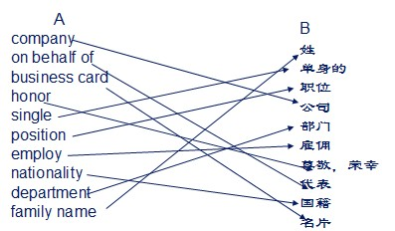
4. Choose the best translation from the three choices .
(1)A (2)B (3)A (4)C (5)A (6)A (7)C (8)A
Section C Reading
Skimming and Scanning
1.B 2.D 3.A 4.A 5.D
6.T 7.T 8.F 9.F 10 F
Reading in Depth
1.A 2.A 3.C 4.D 5.C
6. major, experience, specializes, responsible, intending
Section D Writing
1. List different types of common business writing.
◆Letters of business correspondence
◆Formal documents including speeches, reports, agreements or contracts, bills and forms, etc.
◆Formatted files including memos, notes, notices, invitations, telex, telegrams, etc.
2. Rewrite the wordy expression into concise one.
Wordy Concise
During the year 1998 During 1998
For the reason that Because
With regard to About
In spite of the fact that Even though
We would like to Please
At the present time Now
3. Complete the sentences by translating into English the Chinese given in brackets.
(1) are enclosing a price list
(2) recommend this washing machine
(3) competent lawyer
(4) will appreciate it very much
(5) The application form
4. Complete the following letter with the words and expressions given below.
(1) a casual leave of absence
(2) both days inclusive
(3) a golden opportunity
(4) be very obliged
(5) make them up
5. Write your own application letter using the tips in Step Two.
From: wanglin1980@163.com
Mail to: jacksonyahoo@126.com
Subject: Application for PA

Dear Jackson ,

I am writing to inquire if your company has any opening in the area of PA to general manager. I have long been interested in working for your company. My major is administration management with three years’ experience. I am mature, self-motivated and have strong interpersonal skills.
If any, please reply and I will send you a resume via Email. Thank you for your time.
Looking forward to hearing from you soon!

With kind regards,
Wanglin
Section E Tips for Cross Cultural Communication
Read the following sample and summarize at least three E-mail writing etiquettes with your classmates.
◆ Keep your email short and get to the point.
◆ Use the subject field to indicate content and purpose
◆ Pay attention to the tone of your e-mail.
◆ Avoid using shortcuts to real words, jargon or slang
◆ Be careful with confidential
◆ Sign off your email.

项目一
任务二
Section A Leading-in
Step One The Ice-breaker
1. A baker.
2. An insurance adjuster. She works in PICC.
3. They are buying a car. They are in an auto 4s shop.
Step Two Be All Eyes
1. They are talking about something by phone.
2. One of them is the man’s assistant , while the other is the man’s business partner or friends.
3. Yes, she is.
Step Three Be All Ears
1. C B C C
2. T F T
Step Four Be All You Can Be
activities Asian partner friends importer exporter enjoys reputation contact information
Section B Listening & Speaking
Step One Brainstorming
1.The channels to obtain some information about a new company：
Chamber of commerce
Advertisements
Banks
Newspapers, magazines etc.
Friends or business partners
2. Language Points
(1) Common terms
sales manager 销售经理
children’s garments 儿童服装
business activities 商业活动
specialize in 专营
a leading exporter 一家大出口商
cooperative relationship 合作关系
enjoy a high reputation 享有很高声誉
cotton piece goods 棉布匹
domestically adv.国内地
in this line of work 在该行业
(2) Useful sentence patterns
What do you specialize in?
你们专营什么？
We specialize in textile imports and exports.
我们专营纺织品的进出口。
We would like to expand our business activities into your market.
我们想把我们的业务活动扩大到你方市场。
How long have you been in this line of work?
你们从事该行业多长时间了？
What about your business activities?
你们的经营情况怎样？
We have long-term cooperative relationships with importers and exporters in many Asian countries.
我们和亚洲很多国家的进出口商有长期的合作关系。
Our company enjoys a high reputation.
我们公司享有很高声誉。
There is a great need for cotton garments in our market.
我方市场对棉布服装有大量需求。
Step Two Working and Learning
1. Watch and listen to the conversation. Complete the information by filling in the blanks with proper words.
telephone, information, specialize, Asian, need
2. Listen to the conversations and answer the following questions.
Conversation One
(1)What does ZC Trading Company produce?
Buttons
(2)For what purpose is Hanson calling Chinese Chamber of Commerce?
His company would like to expand its business activities into Singapore and look for an importer.
Conversation Two
(1) How do they obtain the information of the company?
From a newspaper.
(2) What does the company produce?
Buttons.
(3) Why does Mike want to contact it?
He wants to cooperate with it.
3. Match the following words in column A with the Chinese translations in column B.
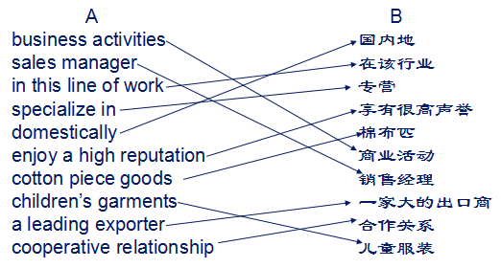
4. Choose the best translation from the three choices .
(1)B (2)A (3)A (4)B (5)B (6)C (7)A
Section C Reading
Skimming and Scanning
1.A 2.C 3.D 4.A 5.B
6.T 7.T 8.F 9.T 10 T
Reading in Depth
1.C 2.A 3.C 4.B 5.D
6. strengthen, promote, provide, potential, platform
Section D Writing
1. Match the following words in column A with the Chinese translations in column B.
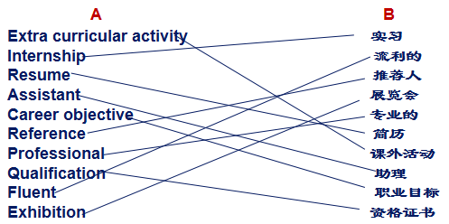

2. Look at following resume of Natalie Wang and put the headings from the box in the correct place in the resume.
（1）Education （2）Work experience （3）Extra curriculum activity
（4）Skills （5）Hobbies （6）References
3. Answer the following questions in pairs.
(1) How many pages does a typical resume contain in your country?
1-2 pages.
(2) Do you include a photo in your resume? Do you think it is a good idea?
Yes. It’s good for your employer to see what you look like./No. People will judge your looks.
(3) Does it have the same headings as Virginia Potts’s resume?
Yes. Most are the same.
(4) Do you include or exclude any other information in resumes in your country
We usually include our age, height, marital status.
(5)Why do you think people put hobbies and interests in resumes?
Because it can show people that you have a passion for life.
(6)What factors do you consider to be the most important in a resume?
Professional skills, work experience and education.
(7)Suppose you are the employer and receive a resume, what do you expect to see?
The candidate’s qualifications, abilities and achievements.
4. Write your own resume using the tips in Step Two.
RESUME
Name: TOBY MA
Phone: 13765219273
E-mail: tobymarcus@gmail.com
Address: 129 Binghe Road, Shenzhen
Objective
External Auditor
Work & Internship Experience
2012-2014 Junior Auditor, Price Waterhouse Coopers, Shenzhen, China
Audited accounts for several companies
Education
2009-2012 Diploma of Accounting & Finance, Shenzhen Polytechnic, China
Course taken: Accounting, Finance, Investment, Economics, International Finance, Corporate Finance, etc.
Awarded first prize scholarship for outstanding academic performance
Skills & Qualifications
Native in English, fluent in English
CPA
Interests & Hobbies
Reading, Hiking, Tennis, Travel
References
Zoe Zhang, Associate Partner, Price Waterhouse Cooper, phone: 13867523986, e-mail: zoezhang@pwc.com
Section E Tips for Cross Cultural Communication
Which one of the following pictures do you think is the appropriate manner when dealing with a new customer?
1. Greeting (C) 
2. Conducting business (B)
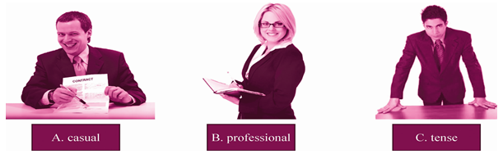

项目一
任务三
Section A Leading-in
Step One The Ice-breaker
The factory probably produce children's garments.
Step Two Be All Eyes
1. He is working at his office.
2. Yes, he is.
Step Three Be All Ears
1. B A A A A
2. F F F
Step Four Be All You Can Be
expressed desire relationship interest information catalogue cooperative
Section B Listening & Speaking
Step One Brainstorming
1.Suggested Working Procedures:
(1) Call potential business.
Try to call at a convenient time;
Formal greetings;
Necessary materials handy;
(2) Introduce your company and ask about their company.
A brief introduction of your company, major products or service;
Questions about potential partner’s company
(1)Express your desire to establish a business relationship.
Express your intention to build up a business relationship;
Send out any materials that the other is interested in.
2. Language Points
(1) Common terms
do a survey 做调查
a promising market 有潜力的市场
financial standing 财务状况
Cotton garments 棉衣
establish business relations 建立业务关系
latest catalogue 最新的产品目录
business partner 生意伙伴
immediately adv. 立刻，马上
be satisfied with 对…满意
do business 做生意
(2) Useful sentence patterns
We did a market survey.
我们做了一个市场调查。
We find your market quite promising.
我们认为你的市场相当有潜力。
We would like to establish business relations with you.
我们想要和你建立业务关系。
We would like/wish/hope to be your long-term business partner.
我们希望能成为你的长期生意伙伴。
We would like/wish/hope to enter into business relations with you.
我们希望和你建立生意关系。
It’s my pleasure to do business with you.
能和你做生意我很高兴。
We are interested in your cotton garments and we would like to learn more about your products.
我们对你的棉衣很感兴趣并且想更多了解一下你的产品。
We will send you our latest catalogue and pricelist immediately.
我们马上给你寄出我们最新的产品目录和价格清单。
We would like to do business with you.
我们想要和你做生意。
We believe you will be satisfied with our products.
我们相信你会对我们的产品感到满意的。
Step Two Working and Learning
1. Watch and listen to the conversation. Complete the information by filling in the blanks with proper words.
survey, promising, partner, cotton, satisfied
2. Listen to the conversations and answer the following questions.
Conversation One
(1)Why did Mr. Green call Mr. Smith?
to require more information.
(2)What did Mr. Green want to have?
a catalogue of plastic buttons.
(3)What is Mr. Smith’s attitude towards Mr. Green?
he is cooperative.
Conversation Two
(1)Did Mr. Green wish to do business with Mr. Smith? Why?
He does not wish to do business with Mr. Smith, because his company changed business activities since last year.
(2)What does his company specialize in now?
It specializes in cotton piece goods.
3. Match the following words in column A with the Chinese translations in column B.
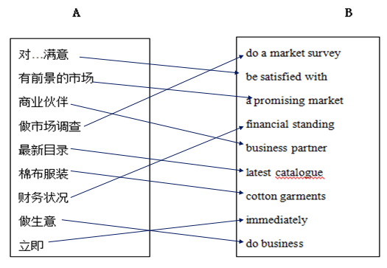

4. Choose the best translation from the three choices.
(1)B (2)A (3)B (4)A (5)A (6)A
Section C Reading
Skimming and Scanning
1.D 2.A 3.A 4.A 5.D
6.T 7.F 8.F 9.T 10 T
Reading in Depth
1.A 2.C 3.C 4.D 5.A
6. significance, maintain, highlights, incorrectly, detailed
Section D Writing
1. Match the expressions in Column A with its Chinese translation in Column B.
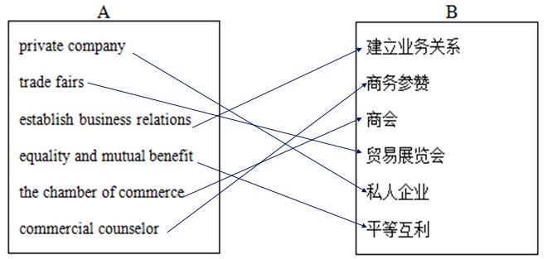
2. Fill in the blanks with the proper words.
(1) to (2) in (3)in (4)for (5)to
3. Translate the following sentences into English.
(1) 因此，我们特此致函，殷切期盼与贵公司建立业务关系。
We are, therefore, writing to you with a keen desire to enter into business connections with you．
(2) 为了让你们大体了解我们的产品， 另封寄上目录一份以及三份小册子供贵方参考。
To give you a general idea of our products, we are sending you separately a catalogue and three pamphlets for your reference.
(3) 从中国国际贸易促进委员会获悉，你们有意购买童装。
We have heard from the China Council for the Promotion of International Trade that you are in the market for children’s garments.
(4)我们的产品在世界市场上十分畅销，以其优良的品质和合理的价格而值得介绍。
Our products are good sellers in the world market and worth recommendation for their excellent quality and reasonable price.
(5)兹介绍本公司为中国最大的丝绸出口商之一，与100多个国家和地区建立有业务关系。
We are one of the biggest exporters of silk in China, having relations with more than 100 countries and regions worldwide.
4. Write an establishing business relationship letter with the following tips.
September 13, 2006
Shanghai Import and Export Corp.
28 Suzhou Road, Shanghai
China
Gentlemen,
Seeing your advertisement in the China Trade Directory, we ask you kindly to send us as soon as possible the latest price list of Chinese synthetic fiber goods, the lowest quotations and an illustrated catalogue.
We are looking forward to receiving your immediate reply.
Yours faithfully
James Taylor
James Taylor & Co.ltd
Section E Tips for Cross Cultural Communication
Are the following statements True or False?
1.F 2.T 3.F 4.T 5.F 6.T 7.T

项目一
任务四
Section A Leading-in
Step One The Ice-breaker
中国进出口商品交易会China Import And Export Fair
中国国际农产品交易会 China Agricultural Trade Fair
第90届中国针棉织品交易会暨中国国际针纺织品博览会
The 90th China Knitwear Cotton Trade Fair and China Knitwear Expo
Step Two Be All Eyes
1.A man is making the telephone call.
2.They could be potential business partners.
3.They are most probably talking about the Canton Fair.
Step Three Be All Ears
1. C C C
2. F F F
Step Four Be All You Can Be
Green catalogue sample product Import & Export reserved invited booths company not sure schedule
Section B Listening & Speaking
Step One Brainstorming
1.Suggested Working Procedures:
(1) Call potential business
Try to call at a convenient time;
Formal greetings;
Necessary materials handy;
(2) Send out the invitation and state your reasons.
Ask about whether they have received your catalogue or other materials;
Send out the invitation, state the time and place as well as the reasons you invite them
(3) Express your appreciation of their acceptance of the invitation.
Express your appreciation of their acceptance of the invitation;
Send out the formal invitation letter as soon as possible.
2. Language Points
(1) Common terms
visit our booths 参观我们的展位
attend our display 参加我们的展示
invitation letter 邀请函
invite…to do… 邀请某人做某事
be salable 卖得出去
appreciate 欣赏、感激
accept your invitation 接受你的邀请
(2) Useful sentence patterns
We wish you will come to attend our display and then visit our company.
我们希望你能来参加我们的展会并参观我们的公司。
We shall appreciate it if you visit our company.
如果你能来参观我们的公司，我们将不甚感激。
We are looking forward to your visit to our company.
我们期待你的来访。
We will send you our formal invitation letter.
我们会送出正式的邀请函。
Have you received the invitation letter from our company?
你收到我们公司的邀请函了吗？
Thanks for your invitation , I will make it on time.
谢谢你的邀请，我会准时到达的。
Step Two Working and Learning
1. Watch and listen to the conversation. Complete the information by filling in the blanks with proper words.
sample, quality, salable, appreciate, invitation
2. Listen to the conversations and answer the following questions.
Conversation One
(1) Who sent Mr. Smith the invitation letter for the Singapore China Commodity Fair next month ? Why?
Joan Zhang sent the invitation. Because she thinks it will be a good opportunity for him to expand his business activities.
(2) Did Mr. Smith accept the invitation?
Yes he did.
Conversation Two
(1)Who answered the telephone? Why didn’t Mr. Green answer it?
Mr. Green’s assistant answered it. Because Mr. Green is out on business.
(2)What did Mr. Smith call Mr. Green for?
He called to confirm whether Mr. Green would go next month.
(3)Did Mr. Green accept his invitation at once? Why?
No he didn’t because he didn’t know.
3.Match the following words in column A with the Chinese translations in column B.
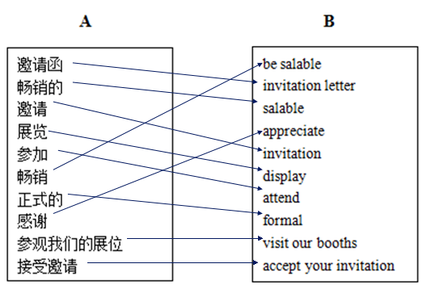
4. Choose the best translation from the three choices .
(1)A (2)C (3)A (4)C (5)A
Section C Reading
Skimming and Scanning
1.B 2.D 3.D 4.A 5.C
6.F 7.F 8.T 9.T 10 F
Reading in Depth
1.C 2.A 3.A 4.C 5.C
6. difference, match, skilled, centered, bottom
Section D Writing
1. Match the expressions in Column A with its Chinese translation in Column B.
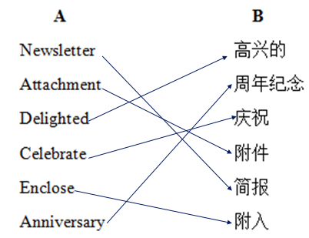

2. Complete the following invitation letter with the words given below.
invite visit provide opportunity understanding future honor enclosed attendance inquiries
3. Translate the following sentences into Chinese.
(1)我很高兴邀请您参加我公司于2014年12月15日在北京举行的新分公司开业仪式。
I am pleased to invite you to attend the opening ceremony of our company’s new branch to be held in Beijing, December 15, 2014.
(2)我写此信的目的是想咨询一下您是否愿意作为嘉宾在典礼上发言。
I am writing to ask whether you would be willing to make a presentation at the ceremony as an invited speaker.
(3)如果您届时能够到场，我们将会非常荣幸。
It would be an honor to us if you could come.
(4)请尽早确认您是否参加会议。
Please confirm your participation in the conference at your earliest convenience.
(5)如果您有任何疑问或需要帮助，请联系主办人王悦小姐。电话13781347356。电邮wangyue@gmail.com
If you have any enquiries or need any assistance, please contact the hostess, Ms. Wang Yue, at 13781347356 or wangyue@gmail.com.
4. Write an E-mail invitation according to the information illustrated below.
Dear Mrs. Hanson,
I am writing this letter to invite you to attend our company’s release of new products conference. The conference will be held in New York on September 9, 2014.
We would be very pleased if you could come. I enclosed the details of the conference in the attachment. We would appreciate it if you could confirm your attendance at your earliest convenience. Should you have any inquiries, please contact my assistant, Ms. Jenny Ross, at telephone: (001) 91736721896 or e-mail: jennyross@stoneheart.com.
Regards,
Peter Quill
Director of Research & Development
Stoneheart Corporation
Section E Tips for Cross Cultural Communication
Directions: Indicate whether the sentence or statement is true or false？
1.T 2.T 3.T 4.T 5.F

项目二
任务一
Section A Leading-in
Step One The Ice-breaker
1. They are at the airport.
Step Two Be All Eyes
1. Two people.
2. They are at the airport.
3. They are greeting to each other after meeting.
Step Three Be All Ears
1. C A B A
2. T F F
Step Four Be All You Can Be
Sales visit country General
Section B Listening & Speaking
Step One Brainstorming
1. Suggested general procedures of taking a plane and other matters that need attention：
General procedures of taking a plane:
Book the air ticket
Arrive at the airport 90 minutes before the departure
Get the boarding pass
Have the luggage checked
Go through the security
Wait for boarding near the boarding gate
2. Language Points
(1) Common terms
flight n. 飞行，航班
board v. 上飞机/船等
luggage n. 行李
parking lot 停车场
delay vt. 延期，推迟；耽搁
journey n. 旅行
boarding pass 登机牌
customs n.关税；海关
security check 安全检查
superb adj. 极佳的，卓越的；质量极高的
considerate adj. 考虑周到的；体谅的；体贴的
(2) Useful sentence patterns
How do you do, Mr. Smith? Thanks for meeting me at the airport.
你好吗，史密斯先生？谢谢来机场见我。
You’re welcome. Very pleased to meet you.
不客气。很高兴见到你。
I’m Rose. I’m here to meet with you on behalf of my company.
我是萝丝。我代表公司来见你。
Excuse me, are you Mr. Hard from America.
打扰一下，请问你是美国来的哈德先生吗？
Mr. Hill asked me to come here in his place to pick you up.
希尔先生让我替他来接你。
Thank you for coming to meet me.
谢谢你来见我。
The car is waiting outside. This way, please.
车在外面。请这边走。
I’m going to accompany you to the hotel.
我会陪您去酒店。
Step Two Working and Learning
1. Watch and listen to the conversation. Complete the information by filling in the blanks with proper words.
Everything enjoyable efficient parking
2. Listen to the conversations and answer the following questions.
Conversation One
(1)Where is Mr. Bush from?
Mr. Bush is from Canada.
(2)Is it Mr. Bush’s first visit to China?
No. But it’s first time to Hangzhou.
(3)How long will it take from the airport to the hotel?
One and a half hour, depending on the traffic.
Conversation Two
(1)When will Mr. Bush go to Canada?
Tomorrow afternoon.
(2)Will the plane be on schedule?
Yes, the plane will be on schedule.
(3)Who will drive Mr. Bush to the airport?
Anne will drive him to the airport.
3. Match the following words in column A with the Chinese translations in column B.
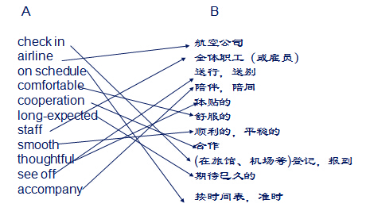
4. Choose the best translation from the three choices .
(1)A (2)B (3)C (4)A (5)C (6)A (7)C (8)B (9)A
Section C Reading
Skimming and Scanning
1.F 2.D 3.A 4.G 5.E
6.easiest 7.unique 8.details 9.As soon as 10.calm
Reading in Depth
1.B 2.C 3.C 4.A 5.D
6. Security 7.check 8.boarding 9.illegal 10.passport
Section D Writing
1. Match the following words in column A with the Chinese translations in column B
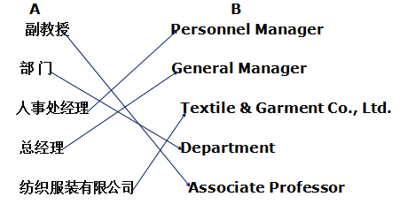

2. Translate the following expressions into English or Chinese
有限公司
Fax
Century Village
外销部经理
人力资源部经理
副院长，副总统，副校长
邮政信箱
名誉主席
机械设备进出口公司
广东省深圳市冬夏区深南西路福田大厦2001室友
3. Find the mistakes in the following business card and correct them.
The right card:
Li Xiang Deputy General Manager
ZHEJIANG XINXING INDUSTRY,CO., LTD
Address: Room2301, South Building, Gongyuan Building,No.1, Wener Road, Hangzhou
P.C: 310012
Tel: 0571-87382845
Fax: 0571-87382836
M./P.: 13575762521
E-mail：wangwn@zdct.net
项目二
任务二
Section A Leading-in
Step One The Ice-breaker
1. He is complaining about something over the phone.
2. She is working as a receptionist.
3. He is carrying a suitcase and covering in sweat.
4. He seems worried after seeing the manager.
Step Two Be All Eyes
1. The man is a receptionist in the hotel.
2. They are in a hotel.
3. They are checking in at hotel.
Step Three Be All Ears
1. A A C B
2. F T T
Step Four Be All You Can Be
Fancy double check key
Section B Listening & Speaking
Step One Brainstorming
1. Suggested working procedures
Get some necessary information from the client for a room reservation: name of the client; fax number; email address; country; city; check-in date; check-out date.
Contact the client for hotel room preference: type of room; room service; hotel location; price
Choose and decide on a proper hotel for the client as required: the hotel name; the hotel class; the location; type of room
Contact the client for confirmation: the hotel name; the hotel class; the location; type of room
2. Language Points
(1) Common terms
Registration n.（住宿）登记
Bellboy n.（男）侍者；行李员
Baggage n. 行李
Service charge 服务费
Suite n. 套房
Double room 双人房
Single room 单人房
Front desk 前台
Receptionist n.（前台）接待员
Room card 房卡
Service counter 服务台;（客房）服务
(2) Useful sentence patterns
What kind of room would you like?
你喜欢什么样的房间？
Would you like a single room or a double room?
你喜欢双人房还是单人房？
Do you have a single room?
你有单人房吗？
Is there a room at the back of the hotel? I want a quiet room.
旅馆后面有房间吗？我想要个安静的房间。
I’d like a double room with a bath.
我想要个带淋浴的双人房。
I’d like a single room with a view.
我想要个看得到风景的单人房。
Can I see the room, please?
请问我能看看房间吗？
How long do you intend to stay?
你想住几天？
May I see your passport, please?
请问我能看看你的护照吗？
Step Two Working and Learning
1. Watch and listen to the conversation. Complete the information by filling in the blanks with proper words.
Single reserved passport sign lovely fantastic pick
2. Listen to the conversations and answer the following questions.
Conversation One
(1)When will Tom’s friend arrive at the hotel?
Tom’s friend will arrive here tomorrow morning.
(2)Can you mention some of the services Tom asks for?
The internet connection, facilities for disabled guests.
Conversation Two
(1)Did John Cummings make a reservation? How long will he stay?
No, he didn’t. Three nights.
(2)What king of room does he want?
A single room overlooking the park.
(3)What service with that?
It includes breakfast, a telephone, a bathroom and a computer with internet access.
3. Match the following words in column A with the Chinese translations in column B.
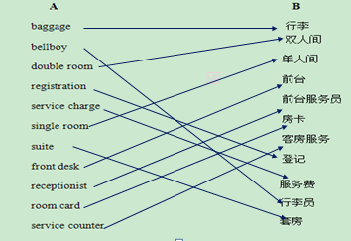
4. Choose the best translation from the three choices .
(1)A (2)C (3)C (4)B (5)C (6)A (7)C (8)C (9)A
Section C Reading
Skimming and Scanning
1.D 2.C 3.D 4.B 5.C
6.F 7.F 8.T 9.F 10.F
Reading in Depth
1.A 2.A 3.C 4.D 5.D
6. convention book available facilities cancel
Section D Writing
1. Match the following words in column A with the Chinese translations in column B
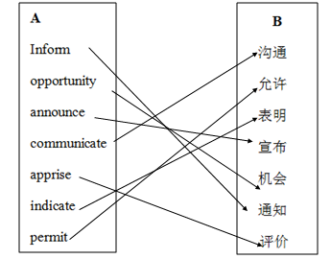

2. Complete the following notice with the words given below.
Task 1: general hereby resident
Task 2: cooperation difference fortunate state-run Donate contribution medicine
3.Translation the following sentences into English.
(1) We inform you that on the 1st of this month, we will establish in this city a Dry-Goods business under the firm name of John-Smith.
(2) We announce you that we have established ourselves as general agents under the title of Chambers Co.
(3) I have the honor to inform you that I have just established myself in this town as a Commission Merchant for Japanese goods.
(4) I have the pleasure of announcing that the business of the old firm of Tokyo &amp; Co., will, from this day, be carried on by me at the same address.
(5) We have opened a new branch in this district, for the convenience of our customers who live here, and for residents who wish to obtain clothing of the newest styles and most reliable quality at reasonable prices.
4.Write a notice according to the information illustrated below
Delhi Public School, New Delhi
Notice
13 April 2007
Meeting of Science Society
On the occasion of National Science and Technology Day, the school has decided to organize a fair. All office bearers are requested to attend a meeting in the School Library on 16 April 2005 at 10 am to discuss the arrangements for the fair.
Vikram
Vikram Singh
(Secretary, Science Society)

项目二
任务三
Section A Leading-in
Step One The Ice-breaker
- Make the invitation. Choose an appropriate restaurant. Make a reservation. Reconfirm with your guests. Arrive early and dress appropriately.
- 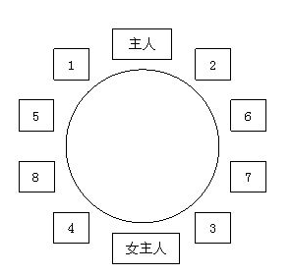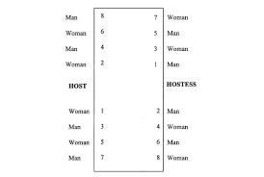

Step Two Be All Eyes
1. The man is a receptionist in the hotel.
2. They are in a hotel.
3. They are checking in at hotel.
Step Three Be All Ears
1. A B C A
2. F F F
Step Four Be All You Can Be
Fruitful satisfied wonderful further toast
Section B Listening & Speaking
Step One Brainstorming
1. Suggested matters need attention
Contact the client for the business dinner preference: Chinese food or western food
Get to know key elements that will make your dining with your clients successful: relaxed atmosphere, good food, convenient time
Get to know some basic rules at a restaurant: money, meet, menu, manner, music, food
2. Language Points
(1) Common terms
menu n. 菜单
appetizer n. 开胃品
meat n. 肉
wine n. 葡萄酒
beverage n. 饮料
salad n. 沙拉
go Dutch 各自付帐，AA制
invitation n. 邀请
fruitful adj. 成果丰硕的
terrific adj. 极好的；绝妙的
recommend v. 推荐
(2) Useful sentence patterns
I wonder if you’ve made any plans for tonight.
我在想你今晚是否有安排。
My secretary will pick you up later.
稍后我的秘书会来接你。
Would you like to order now?
你想现在点单吗？
Would you like to try our grape juice?
你想试试我们的葡萄汁吗？
Here comes our first dish. Help yourself, please.
这是我们的第一道菜。请用。
This food is the best that I’ve ever tasted.
这是我吃过的食物里味道最好的。
Can I see the room, please?
请问我能看看房间吗？
Help yourself to whatever you like.
请随意点你喜欢的东西。
I’m full. I have no room for ice cream.
我吃饱了。吃不下冰淇淋。
Step Two Working and Learning
1. Watch and listen to the conversation. Complete the information by filling in the blanks with proper words.
Follow order recommend specialty rare well-done dessert diet juice
2. Listen to the conversations and answer the following questions.
Conversation One
(1)When will Mr. Will be picked up from the hotel lobby?
He will be picked up at five the next evening.
(2)Is the contract they signed yesterday the last one?
No. They will have more in the future.
Conversation Two
(1)What would Mr. Cotton like to have for an appetizer?
Grape wine.
(2)What is Mr. Cotton’s suggestion?
If the price were 10% off, more orders would follow.
3. Match the following words in column A with the Chinese translations in column B.
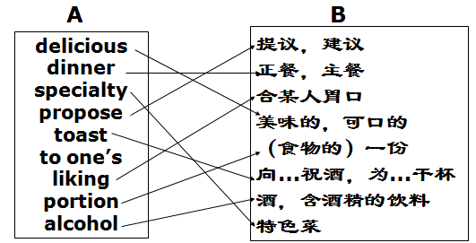
4. Choose the best translation from the three choices .
(1)C (2)A (3)B (4)A (5)B (6)C (7)C (8)A (9)C
Section C Reading
Skimming and Scanning
1.D 2.F 3.B 4.A 5.E
6.F 7.F 8.F 9.T 10.F
Reading in Depth
1.C 2.D 3.D 4.A 5.B
6. Typical western food from the above pictures:
Scrambled eggs or omelets, bacon, sausage, toasted bread, and waffle with butter. Pizza with salads, burger with chips.
Typical Chinese food from the above pictures:
Fried bread stick , sesame ball, soybean curd, salted duck egg , Chinese rice wine, zongzi(rice dumpling ), steamed bun and dumpling.

Section D Writing
1. Match the following words in column A with the Chinese translations in column B
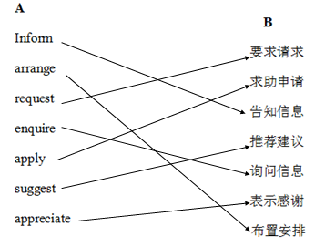

2. Complete the sentences with the words and expressions given below.
Department come dropped into comparison get back on track stick to deadlines targets measures increased Regards
3.Write a notice according to the information illustrated below
Memo
To: all staff
From: Ana Lucily, Fire Safety Officer
Date: September 26, 2012
Following the recent fire drill, I find it necessary to remind you all of the following fire regulations:
1. Take the fire alarm seriously.
2. When the fire alarm is sounded, go to the courtyard immediately.
3. Do not go to the basement to collect you belongings.
4. Report to your supervisor.
These regulations are for your safety. Your cooperation will be appreciated.
Best regards,
Ana Lucily, the Fire Safety Officer

项目二
任务四
Section A Leading-in
Step One The Ice-breaker
1.无论到哪里，随心而动。
我乃行者非游客
与其富可敌国眼界寥寥，我宁愿粗茶淡饭走遍天下
2.The Great Wall Potala Palace The Terracotta Army Yungang Grottoes Yellow Mountain West Lake
Step Two Be All Eyes
1. They are business partners/friends.
2. Tourist attractions in China (the bund and the Oriental Pearl Tower in Shanghai, classical gardens in Suzhou, West Lake in Hangzhou).
Step Three Be All Ears
1. C B C A
2. F F T
Step Four Be All You Can Be
Setting up particular leaves Tower classical gardens upper below
Section B Listening & Speaking
Step One Brainstorming
1. Suggested matters need attention
Ask the client about his interests in the attractions: tourism information; look for popular scenic spots; ask client in a polite manner; try to adjust the itinerary if the client intends to go some other attractions;
Get necessary information on the background of the scenic spot you have planned for your client: Basic knowledge about the scenic spot; culture behind; all the major stories that relate to the place; travel route;
Guide your client to the attractions and introduce them to him: Explain the basic information of the attractions, deliver some relate history or stories behind; lead the route in a polite manner

2. Language Points
(1) Common terms
tourism n. 旅游；旅游业
heritage ['herɪtɪdʒ] n. 遗产；传统
attractions n. 旅游景点
itinerary [aɪ'tɪnərɛri] n. 旅程，路线
travel agency n. 旅行社
tourist coach n. 游览车；观光巴士
tourist city n. 旅游城市
tour route n. 旅游路线
souvenirs ['sʊvə,nɪr] n. 纪念品
tourist brochure [bro'ʃʊr] n. 旅游手册
natural scenery n. 自然风光
places of interests and historical spots 名胜古迹
(2) Useful sentence patterns
Does China have great tourism resources?
中国有什么好的旅游资源？
Yes, there are many places of interest and historical sites.
有，中国有很多名胜古迹。
Does it attract sightseers from around the world?
这个景点能吸引全世界的人来参观吗？
Of course, along with China's economic development, the number of tourists to China is increasing.
当然了，随着中国经济的不断发展，来中国游客也在不断增长。
The view is wonderful from up here.
从这儿看风景美极了！
Winter is the best time to visit because... .
冬季是最佳观光季，因为... 。
It’s a very popular place and it admits a limited number of tourists a day.
这景点非常受欢迎，他们对每日的游客数量有限制。
Part of the sightseeing is tasting local specialties.
品尝当地特色小吃也是观光的一部分。
These are natural wonders.
这些都是自然界的奇迹
Step Two Working and Learning
1. Watch and listen to the conversation. Complete the information by filling in the blanks with proper words.
Four scenic spots details poet winter brochure symbol
2. Listen to the conversations and answer the following questions.
Conversation One
(1)Does Claire arrange a tour for herself in Beijing? If not, why?
Not yet, because she is new here.
(2)How long is the main part of the Great Wall?
About 3,400 kilometers.
(3)When was the Great Wall built?
It was firstly built during the state of Chu, and was formed in Qin Dynasty.
Conversation Two
(1)What do people say about Guilin?
The landscape of Guilin is the finest in the world.
(2)What is Guilin famous for?
Guilin is famous for its scenic beauties
(3)Where is Guilin?
Guilin locates in the north-east of Guangxi Province.
3. Match the following words in column A with the Chinese translations in column B.
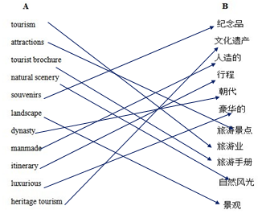
4. Choose the best translation from the three choices .
(1)C (2)A (3)B (4)C (5)C (6)C (7)A (8)B (9)A
Section C Reading
Skimming and Scanning
1.A 2.C 3.C 4.D 5.A
6.F 7.F 8.T 9.F 10.T
Reading in Depth
1.D 2.C 3.B 4.A 5.B
6. wild conquered upset demand Temple
Section D Writing
1. Fill in the blanks of following letter with the words given below and change the form when necessary
E C A D B
2. Rearrange paragraphs to make the letters correct.
Letter 1:
Dear Mr. XXX,
Our visit to your company and your country is drawing to a close and we are leaving for China shortly.
On the eye of our departure, it gives me great pleasure to write to you on behalf of my colleagues and myself to say “Thank you”. We appreciate very much your hospitality to us during our stay here. This has been a fruitful visit and we are confident of its importance to our future export business to the States.
My colleagues and I are looking forward to seeing you in China soon, when we could examine once again how to push the relationship between us.
We wish you good health and every success in your dealership here.
Best regards,
XXX
Letter 2
Dear Mr. White,
Thank you for taking the time to discuss the marketing position with me.
After the meeting with you, I am sure you will that find my professional background and skills match the requirements of the job offered.
In addition to my education and experience, my communication as well as people skills will prove to be an asset for this job.
I look forward to hearing from you with a positive reply from your part. I appreciate your consideration.
Sincerely,
XXX

3.Translate the following letter into Chinese
主席先生：
感谢您昨晚的宴请。
餐前的讨论对我们非常有帮助。
我确信未来我们双方将有长久愉快的合作。
此致
敬礼!
XXX

项目三
任务一
Section A Leading-in
Step One The Ice-breaker
1. Do you know the structure of a company?
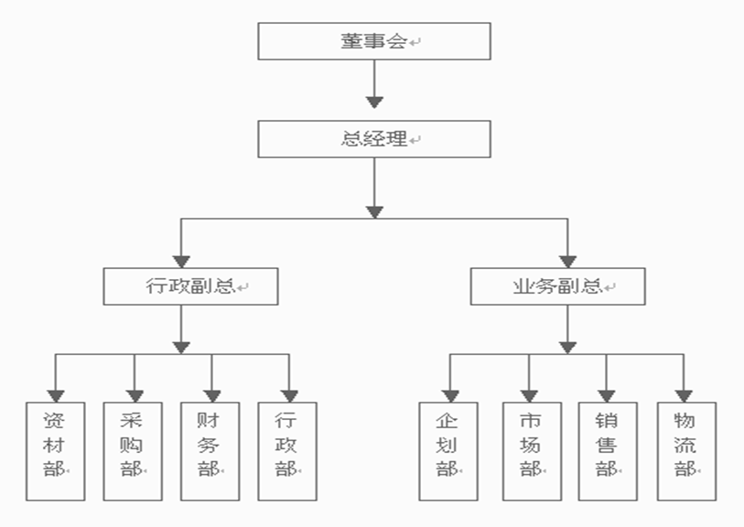
Step Two Be All Eyes
1. They are in the factory.
2. The woman is introducing the factory to the man.
Step Three Be All Ears
1. A C B
2. F F T
Step Four Be All You Can Be
first look Southeast of HZ in 2006 300 employees textile products
Section B Listening & Speaking
Step One Brainstorming
1. Suggested Working Procedures
(1) The preparation of the reception:
The name of clients
The reception staff
Meeting room
(2) Visiting procedure
Where to go: Sales Dept., Transportation Dept. Quality Control Dept. etc.
What to see: environment, scale of the company
Introduce yourself without stopping.
(3) An introduction to a company
Location
Scale
Employees
Turnover
2. Language Points
(1) Common terms
Financial Dept. 财务部
Marketing Dept. 市场部
Personnel/ HR Dept. 人力资源部
Production Dept. 生产部
Sales Dept. 销售部
Transportation Dept. 运输部
CEO 董事长
CFO 财务总监
(2) Useful sentence patterns
Our company is headed by….
我们的公司是由……
We are a manufacturing company with more than 3000 employees.
我们公司是一家生产制造公司，拥有3000多名员工。
Our headquarters are in China.
我们公司总部在中国
Our company is divided into six departments.
我们公司有六个部门。
Our company was founded in 1977.
我们公司成立于1977年。
Our annual income in 2003 was about 90 million U.S. dollars.
我们2003年年收入是9亿美元。
Step Two Working and Learning
1. Watch and listen to the conversation. Complete the information by filling in the blanks with proper words.
Opportunity; brief; divided; come; responsible; customers;
2. Listen to the conversations and answer the following questions.
Conversation One
(1) Who will make the presentation about the company?
Ms. Huang will give a brief presentation about the company.
(2) How many parts does Ms. Huang give in her presentation? What are they?
She talks about her company from three points of view: first, the history of the company. Second, their main markets and the main products. Third, their customers.
Conversation Two
(1) How many functional departments are there in your company?
There are three divisions. Board of director, managerial tier and laborial tier.
(2) Does the company have its own factories?
Yes, they have four in suburb.
(3) Where is the company’s office?
On the third floor.
3. Directions: Translate the following phrases.
代表 on behalf of
很荣幸 be great honored
有机会 have the opportunity to do something.
Human Resources Dept. 人力资源部
R&D Dept. 研发部
Financial Dept. 财务部
Sales& Marketing Dept. 销售市场部
the Production Dept. 生产部
4. Choose the best translation from the three choices.
(1)A (2)C (3)C (4)B (5)A
5. Directions: Answer the following questions.
(1) What’s the function of the Production Dept.?
The Production Dept. is the department
responsible for physical creation of product.
(2) What’s the function of Sales Dept.?
It is to find new customers and make sales.
Section C Reading
Skimming and Scanning
1.B 2.D 3.C 4.C 5.B
6.T 7.T 8.T 9.F 10 F
Reading in Depth
1.D 2.B 3.A 4.D 5.A
6. loan, hone, one-stop, down-sizing, bulk
Section D Writing
1. Directions: Complete the sentences with words and expressions given below.
(1) are in the market for
(2) place an initial order for
(3) have an inquiry
(4) appreciate it
(5) quote us rock-bottom prices
2. Directions: Choose the best answer to each of the following sentences.
(1)D (2)A (3)D (4)A (5)A (6)
3.Directions: Find the mistakes in the following sentences and correct them.
(1) Please let us have details of your air conditioners and give us your earliest delivery.
(2) We would appreciate it if you quote your best prices CIF London.
(3) We hope to receive your quotation in details to include the possible time of shipment.
(4) Will you please send us your lowest prices for the items listed below?
(5) Would you like to send us samples of your cotton shirts?
4. Directions: Write an inquiry letter with the following tips.
Dear Sirs,
We have learned your name and address from the October issue of Foreign Trade. We are interested in buying large quantities of steel screws in all sizes.
We would appreciate it if you would give us a quotation per kilogram C&F Liverpool, England. It would also be appreciated if you could forward samples to us.
We look forward to hearing from you.
Sincerely,
XXX
Section E Tips for Cross Cultural Communication
Directions: Suppose you are in charge of receiving visitors from other companies, which of the following behaviors are inappropriate for you to leave a good first impressions on the visitors?
◆ Be casual is OK
◆ Shaking hands with a guest
◆ Offering drinks and refreshments

项目三
任务二
Section A Leading-in
Step One The Ice-breaker
1. What is the room for? What do we call it?
It is a room to display the products. It is called a showroom.
2. Where are they? What are they doing?
They are in a factory. They are making garments.
Step Two Be All Eyes
1. They are in the factory.
2. Zhu is showing Jenny around the factory and explain the operations.
Step Three Be All Ears
1. B A A
2. F F T
Step Four Be All You Can Be
Warehouse surprised 50000 in the early 2000s time 10th
Section B Listening & Speaking
Step One Brainstorming
1.Suggested working procedures
(1)The preparation of the reception
The name of clients
The reception staff
Meeting room
(2)Visiting procedure
Where to go: the plant, the showing room, etc.
What to see: environment, production process, scale of business line, samples
(3)Showing samples
Illustrated catalogue
Classical samples
2. Language Points
(1) Common terms
Sample room 样品室
catalogue 目录
colorful 色彩绚丽的
superior 高级的
capacity 能力、容量
plant 车间、设备、工厂
(2) Useful sentence patterns
The goods are in different qualities.
产品质量不同
Our products are high in quality and low in price
我们的产品物美价廉。
Our garments are made from cotton.
我们的服装师全棉制造。
This kind of bicycle can be folded in half. It’s handy to carry around, especially useful during traveling and traffic jams.
这款自行车可以对折，特别是在旅游和交通拥堵的时候， 方便随身携带。
What size do you need?
你需要什么尺寸？
What style do you want?
你喜欢什么款式？
How about this one?
这款怎么样？
May I see others in a different style?
我可以看看其他款式吗？
What are the specifications of the product?
这款产品的规格是怎么样的？
We recommend this article for its high quality and modern design.
我们向您推荐这款质量好，设计时尚的产品。
Step Two Working and Learning
1. Watch and listen to the conversation. Complete the information by filling in the blanks with proper words.
Well-made classic genuine color international
2. Listen to the conversations and answer the following questions.
Conversation One
(1) Which section do they begin to visit?
They start with assembly line.
(2) Is the production line automated?
No, it is not fully automated.
Conversation two
(1) what’s Janet’s general impression on the factory?
Very impressive, especially the speed of your new model.
(2) what’s the advantage of the new model?
The speed.
3. Directions: translate the following phrases.
四出走走 walk around
样品间 sample room
国际标准 international standard
Well-made 做工良好
Meet one’s satisfaction 满足某人需求
Genuine leather 真皮
4. Directions: Match the following words in column A with the Chinese translations in column B.
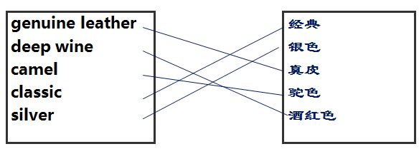
5. Directions: Choose the best translation from the three choices.
(1) A
(2) B
(3) B
(4) A
(5) C
Section C Reading
Skimming and Scanning
1.D 2.A 3.D 4.C 5.B
6.finest 7.Long Island 8.Snack 9.heart 10 1866
Reading in Depth
1.A 2.D 3.C 4.B 5.D
6. packaging, exhibit, Highlight, stadium, up to

Section D Writing
1. Directions: Match the expressions in Column A with its Chinese translation in Column B.
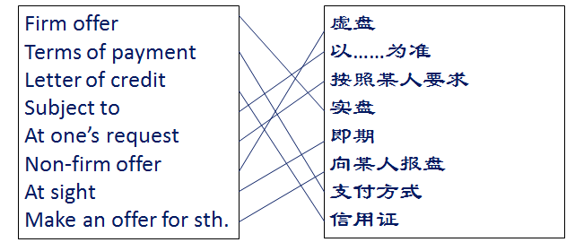

2.Directions: Combing the following parts into sentences
(1) We offer 500 Phoenix Brand bicycles at USD50 per set, CIF London for shipment in April, subject to your reply reaching here on or before February 28th
(2) We always try our best to meet your requirements in view of our long relations.
(3) As you know, our goods are superior in quality and reasonable in price, so they are popular in the overseas market.
(4) Please make us an offer for 20 metric tons of
brown cashmere CIF London.
(5) This offer is subject to the goods being unsold on receipt of your reply.

3. Directions: Translate the following sentences into English.
(1) This offer is subject to your reply reaching here before May 10.
(2) Please open the L/C in our favor immediately.
(3) Our products are high in quality and low in price.
(4) Please quote us lowest price for 2000pcs of wool sweaters FOB Qingdao including 2% commission for August shipment.
(5) Thank you very much for your inquiry about leather clothes. Now we are making an offer as follows and waiting for your order with keen interest.

4. Directions: Write an offer letter with the following tips.
Dear XXX,

Thank you for your letter yesterday. Now we are making an offer for 1000 pairs for leather gloves at USD4.00/ pair CFR Singapore , for shipment before Nov. 12, 2014. This offer is firm, subject to the receipt of your reply before Aug. 31, 2014.

As you know, there has recently been a heavy demand for these commodities and this has resulted in increased prices. You may, however, take advantage of the strengthening market if you send an immediate reply.

Sincerely yours,
XXX
Section E Tips for Cross Cultural Communication
Do’s and Don’s
Men
Do wear your suit jacket when you conduct business outside your office. Your authority travels with you.
Do polish and maintain dress shoes.
Do keep hair and nails clean and neat.
Do wear appropriate jewelry.
Do not overpower your appearance with heavy cologne (古龙香水)!
Do not wear short-sleeved shirts under suit coats. Showing a clean cuff is a must.
Do not wear ankle socks or light colored socks with a dark suit.
Women
Do wear a suit when you conduct business outside your office.
Your authority travels with you.
Do wear comfortable shoes and hosiery (丝袜) to complement your outfit.
Do wear natural looking makeup.
Do wear appropriate jewelry.
Do keep hair and nails clean and neat.
Do not overpower your appearance with heavy perfume!
Do not wear elaborate (复杂的) hairstyles.
Do not wear jeans or casual slacks(便裤) .
Do not wear trendy fashions---unless a trendy appearance is appropriate for your industry.

项目三
任务三
Section A Leading-in
Step One The Ice-breaker
1. They are at the Canton Fair. Yes. (Open)
2. Toys. Washing machines.
3. 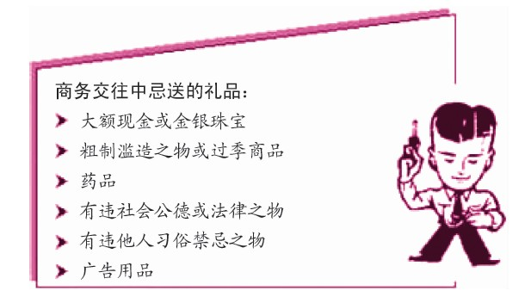

Step Two Be All Eyes
1. They are partners.
2. They are talking about knitted sweaters.
3. No, they aren’t.
Step Three Be All Ears
1. C A A C
2. F T F
Step Four Be All You Can Be
70% wool and 30% spandex the style if long sleeves short sleeves round neck v-neck two days
Section B Listening & Speaking
Step One Brainstorming
1.Suggested working procedures:
(1) sample preparation
Classification of samples
Details about samples
(2) have a good knowledge of your products
The composition
The technical
The price
2. Language Points
(1) Common terms
favorable 有利的、令人喜欢的
place an order 下订单
casual boots 休闲鞋
unique 独特的、唯一的
classic 典型的、传统样式的
elegant 漂亮的、简洁的
springy 有弹力的
skillful 灵巧的、熟练的
capacity 最大限度的
attractive 吸引人的
durable 耐用的
fashionable patterns 样式时尚
(2) Useful sentence patterns
Do you have any special requirements?
你们有特别要求吗？
This is our newly developed product. Would you like to see it?
这是我们新开发的产品，想看看嘛？
This material has a durable and easy-to-clean surface.
这种材料耐用容易清洗。
They are not only as low-priced as other markets, but they are also superior in the following respects.
我们的产品不仅价格较同类产品低，而且在其他方面更优越。
You could be interested in seeing our new products.
您一定想要看看我们的新产品。
We’re sure you’ll be satisfied with this new product.
我们相信你们一定会对新产品满意。
There is a great demand here for this kind of goods.
本地对这类产品有大量的需求。
Our products are superior in quality and reasonable in price。
我们的产品物美价廉。
Step Two Working and Learning
1. Watch and listen to the conversation. Complete the information by filling in the blanks with proper words.
term, offer, interests, market, L/C
2. Listen to the conversations and answer the following questions.
Conversation One
(1) What kind of products does Linda supply?
They can make various for different needs like ladies’, men’s’, children’s.
(2) What kinds of goods is David interested in? Why?
He is interested in ladies’ sweater with silk. You know, these kind of
goods are more saleable in our market.

Conversation Two
(1) What is the main target market for the seller?
Their main clients are USA and UN countries, such kinds of sweaters find a favorable reception there.
(2) Why are their products attractive?
Because they are bright in color, beautiful in design, excellent in quality and attractive in price.
3. Directions: Match the following words in column A with the Chinese translations in column B.
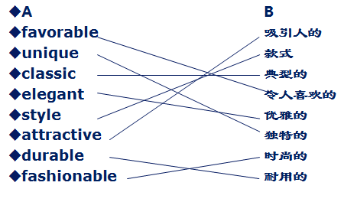

4. Directions: Fill in the blanks with proper words.
Look high low bright beautiful selling well an order interested
Section C Reading
Skimming and Scanning
1.A 2.C 3.D 4.B 5.B
6.T 7.F 8.F 9.T 10 T
Reading in Depth
1.C 2.D 3.B 4.D 5.A
6. paid off, straightforward, blow, update, position
Section D Writing
1. Directions: Match the expressions in Column A with its Chinese translation in Column B.
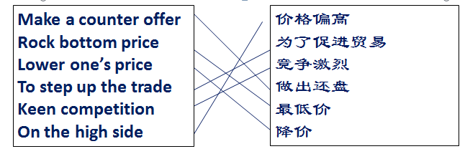
2. Directions: Fill in the blanks with appropriate words or expressions given below.
(1)up; as
(2)price; on
(3)demand; for
(4)at
(5)no
3. Directions: Translate the following sentences into English.
(1) In view of our long-standing business relationship，we will accept your offer.
(2) To step up the trade, we make a counteroffer as follows, subject to your reply reaching us on or before May 10.
(3) We make a counter-offer to you of USD150 per metric ton CIF London.
(4) The price you offered is on the high side, so it is beyond what is acceptable to us.
(5) Your offer is acceptable but we are not in a position to make payment by L/Cat sight.
4. Directions: Write a counter offer letter with the following tips.
Dear Sirs,

Thank you for your offer on 15th July for 100 dozens cigarette lighters.

While appreciating your kind offer, we have to say that USD 80.00 per pair seems to be too high. As you probably know, the cigarette lighters available at present on the market manufactured by several Taiwanese factories are of good quality, and the prices are 10-15% lower than yours.

We wonder if you would kindly consider reducing the price to USD 70.00 per dozen. If you could come down to this price level, we might be able to order 100 dozen.

Your consideration of this matter and immediate reply would be appreciated.
Yours faithfully,
×××

Section E Tips for Cross Cultural Communication
(open)

项目三
任务四
Section A Leading-in
Step One The Ice-breaker
1. They are in a heated discussion.
2. The document is called contract.
They are going to sign it.
Step Two Be All Eyes
1. In the office
2. He wants to order some of their products.
3. She is introducing their products to the man.
Step Three Be All Ears
1. A B B C A
2. T F F
Step Four Be All You Can Be
purchasing long 50% 50% 2000pcs 400g black white USD5.17 Section B Listening & Speaking
Step One Brainstorming
1. Suggested working procedures
(1)Inquiry
The requirements of the goods you need such as the name of commodity, the composition, the style, the color, the quantity and the unit price as well.
(2) Offer
The unit price, trade terms, shipment, insurance, terms of payment ;
The validity period of the offer
(3) Counter-offer
The discount you could make.
The lowest price you could accept.
(4) Acceptance
Congratulation
Best wishes
2. Language Points
(1) Common terms
enquiry 询价
Offer 报价
counter offer 还价
acceptance 接受
letter of credit 信用证
telegraphic transfer 汇付
collection 托收
the date of shipment 装运期
insurance 保险
claim 索赔
firm offer 实盘
non-firm offer 虚盘
usual practice 惯例
(2) Useful sentence patterns
表示询问价格的表达方式有：
How much is this?
How much does it cost?
What is the price, please?
Is tax included?
表达报盘有效期的表达方式有：
How long does your offer remain valid?
This offer will be/remain effective/ open/ valid/ firm for a week from…
This offer expires on August 8.
表示价格太高的表达方式有：
What would be your lowest price for your product?
That’s far more costly than I expected.
Your prices are beyond our expectation.
I’m afraid I can’t agree with you there.
表示价格低的表达方式有：
This is our wholesale price/ retail price/ producer’s price. 这是我们的批发价/ 零售价/ 出厂价。
This is our lowest price.
This is price as low as we can go.
表达要求降价的表达方式有：
Can you give me a discount?
How much can you take off the price? 可以便宜多少？
I’ll take it if you give me a 20% discount.
Can we both make some concession?
Let’s meet each other half way.
表示成交的表达方式有：
Great! We have a deal!
Perfect! That's a deal!
Deal!
Done!
Let’s call it a deal.
Step Two Working and Learning
1. Watch and listen to the conversation. Complete the information by filling in the blanks with proper words.
fashionable, subject, beyond, lower, reduce, up-to-date, long-term, conclude
2. Listen to the conversations and answer the following questions.
Conversation One
(1) What is the reduction in the price that Daisy made?
Possible Key: Daisy suggested that both party would make some concession by reducing the price by 0.5/pc.
(2) . Did Lynn agree with Daisy’s price? What’s Lynn’s suggestion?
Possible Key: No, she didn’t. Lynn suggested to make a reduction by USD0.3/pc
Conversation Two
(1) Does “producer’s price” mean “the cost of production”?
Possible Key: Yes, it does. That means the lowest price.
(2) Do they conclude the business?
Possible Key: Yes, the seller gave a discount of 2%.
3. Match the following words in column A with the Chinese translations in column B.
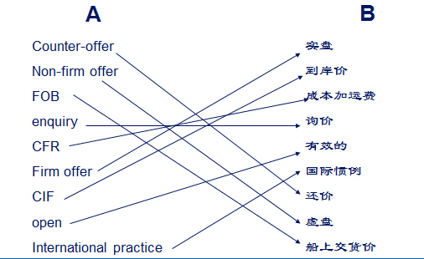

4. Choose the best translation from the three choices .
(1)A (2)B (3)A (4)C (5)A (6)C
Section C Reading
Skimming and Scanning
1.B 2.D 3.A 4.E 5.F
6.F 7.T 8.F 9.T 10 F
Reading in Depth
1.D 2.C 3.A 4.B 5.C
6. shoulder to shoulder, feedback, internal, act on, leadership
Section D Writing
1. Directions: Directions: Match the expressions in Column A with its Chinese translation in Column B.
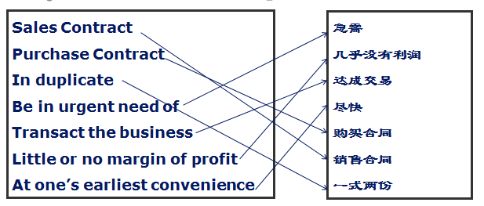

2. Directions: Fill in the blanks with the words given below and change the form when necessary.
(1) received (2) confirm (3)as follows (4)made (5)terms (6)appreciated (7) contact
3. Directions: Find the mistakes in the following sentences and correct them.
(1) We find both quality and prices satisfactory and are pleased to give you an order for the following items.
(2) You may rest assured that as soon as we are able to accept new orders, we shall give priority to yours.
(3) If you can supply your goods immediately, we shall be prepared to place a prompt trial order.
(4) Accepting the price you offer would leave us only a small profit in our sales.
(5) We are pleased to have transacted this initial business with you and anticipate receiving your further orders.
4. Directions: Write an acceptance with the following tips.
Dear Sirs,
Thank you for your letter yesterday.
We confirm the details of your order for 2000 boxes of CD at $5.00 per box, totaling $10,000.00. We agree to your quoted prices as stated above and anticipate receiving the goods on or before Nov. 12.
Thank your for your cooperation and await your early reply.
Best wishes,
XXX
Section E Tips for Cross Cultural Communication
Corporate Gift Considerations
1. Follow Company Policy
Not every company allows their employees the luxury of accepting gifts. Check with the company’s secretary or human resources department before sending anything over. This will avoid possible embarrassment on your part if the recipient is required to turn your gift down. Better safe than sorry.
And be sure to double check your own company's policy for gift-giving as well. They may have limits on the amount you can spend per gift.
2.Avoid The Appearance of Impropriety
Think about your relationship to the recipient. Are you long-time business colleagues? Is this a new business relationship? Are you hoping to gain the client’s business? Never send a gift in the hopes of favorably influencing a business decision. Even with the best of intentions, this could be construed as unethical business practice and you may end up losing the deal. When in doubt, send a formal, handwritten note on excellent card stock instead.
3. Choose Tasteful Gifts
Choose a gift that’s tasteful and understated. Sending any item with your logo boldly emblazoned in blaring letters across it will look cheap. Yes, you want your logo out there and you want your client to remember you. But sending a garish gift with little value will only make your gift seem cheap. Instead, select a high-quality item that’s of use. A digital photo frame or a pewter desk clock are wise choices. Then, have your logo engraved in a small font along with a message.
4. Consider The Entire Team
Consider the whole team before sending a gift. Was there a pool of designers or engineers who backed up the boss and made your year profitable? Did you work with a group of particularly helpful secretaries and account executives? Send a gift everyone can partake in like an upscale fruit basket from All About Gifts & Baskets or Harry & David or even a fresh baked cookie gift from a local or online bakery.
5. Timing
During non-holiday seasons, certain gifts or sending them at certain times may send the impression that you have an ulterior motive for giving it. You should never, for example, send a gift when in contract negotiations. Sending gifts to someone you have never done business with may seem like an attempt to win their business. Likewise, sending a gift to a former client may make it seem like a bribe to get her business back.

